whistleblowing@thyssenkrupp rothe erde Slovakia, a.s.

At thyssenkrupp rothe erde Slovakia integrity, compliance with the law and internal regulations are of highest priority. To ensure that these values are upheld and potential risks arising from violations are avoided or minimized, it is crucial that misconduct is identified, clarified, and remedied at an early stage. Every indication of a potential misconduct is treated seriously and leads to an investigation following an objective and transparent process without any bias. thyssenkrupp rothe erde Slovakia therefore makes available to whistleblowers in compliance and under protection of the Slovak Whistleblowing Act, an internal information system that enables whistleblowers to submit reports.
The Slovak Whistleblowing Act transposed the Directive (EU) 2019/1937 of the European Parliament and of the Council of October 23, 2019 on the protection of persons who report breaches of EU laws as well as serious criminal and administrative offenses under Slovak law.
Since July 1, 2023 entities with more than 50 employees need to implement the according measures, especially the activation of a reporting channel and establishment of investigation procedures that guarantee, among others, the confidentiality of the report and the protection of the whistleblower against disclosing its identity and any retaliation resulting from the report.
A detailed description of thyssenkrupp rothe Erde Slovakia´s Investigation Principles and Rights and Duties of Whistleblower can be found as attachment of this page.

Who can inform about a violation?
The whistleblower is the natural person who submits the report or makes a public disclosure of information on violations acquired in the context of his or her work. Reporting can be done through multiple channels by:
- staff with an employment relationship
- self-employed workers
- freelancers and consultants, suppliers, customers
- volunteers and trainees
- shareholders or owners of company shares persons with administrative, management, supervisory or representative functions
- any person working for or under the supervision and direction of contractors, subcontractors and suppliers.

What can be reported?
Violations of internal regulations and/or applicable laws listed in the Slovak Whistleblowing Act, violations of human rights and environmental-related breaches of duty or risks as well as breaches of European law can

be reported through a variety of channels. Even indications or suspicions of violations can be reported and will be treated seriously. Therefore, in this document “violations” will refer to both actual and potential violations.

Who is responsible for dealing with reports?
thyssenkrupp AG has established Compliance Investigations Department (CO/L&C-INV) with its autonomous and specifically trained personnel as “System Manager” to support thyssenkrupp rothe erde Slovakia with the tasks of receiving reports and conducting investigations. The respective Compliance Investigation Officers are impartial, independent, are not bound by instructions with regard to investigations and sworn to secrecy. Incoming reports, that can also be submitted anonymously, are treated confidentially and whistleblowers are protected by all appropriate means against any disadvantages resulting from a report.
Whistleblowers may submit a report through various channels described below. The System Manager together with the tk Group Function Internal Auditing (“CO/AUD”) and the Compliance Manager, will agree on adequate investigation procedures and propose adequate measures to thyssenkrupp rothe erde Slovakia, if necessary.

How can I submit a report?
An open communication culture is an essential component of well-functioning compliance. Employees must be able to address potential violations openly, anonymously and, above all, at an early stage.
For this purpose, thyssenkrupp rothe erde Slovakia makes a number of internal whistleblowing channels available which are set out below:

4.1 thyssenkrupp Electronic Whistleblowing System (BKMS)
The Compliance Whistleblowing System of thyssenkrupp can directly be accessed under https://www.bkms-system.net/thyssenkrupp-slo or by scanning the QR code below:
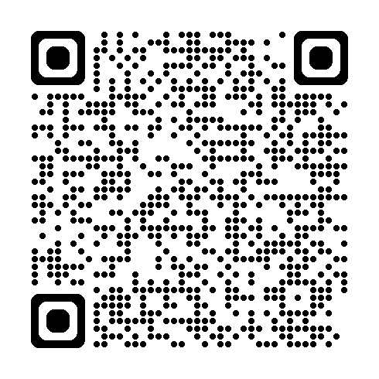
(The link or QR code will take you to the Compliance Whistleblowing System in Slovak. You can select another language on the landing page, e.g. English or German, to submit your report in the Compliance Whistleblowing System.)
In addition to the Compliance Whistleblowing System, violations regarding the International Framework Agreement (thyssenkrupp internal HR violations) can also be reported to representatives on the International Committee and the Labor Relations department at thyssenkrupp AG under https://www.bkms-system.net/frameworkagreement

4.2 Telephone Hotline
thyssenkrupp contact via the following telephone number selecting Slovak language (automated telephone dialog):
Phone: 00 48 22 1523361
Access PIN: 4541

4.3 Contacts within thyssenkrupp Headquarters
thyssenkrupp Headquarters can be reached via the following contact details :
thyssenkrupp AG,
Compliance, Department Investigations
thyssenkrupp Allee 1,
45143 Essen, Germany

whistleblowing@thyssenkrupp.com

4.4 Contacts within thyssenkrupp rothe erde Slovakia
Robotnícka ul.
017 01 Považská Bystrica

If you work for thyssenkrupp, you can also contact your compliance manager responsible for your company directly. A detailed list of contacts is available on the intranet.
Please note: If a face-to-face meeting is requested, it will be organized within 7 days. If the report is submitted orally, with prior consent of the whistleblower, the report is documented in a secure, durable and accessible format, or by a transcript of the conversation. The whistleblower may be given the opportunity to verify, rectify and confirm the minutes of the meeting by signing them.
More information on the submission of reports to thyssenkrupp can be found here: Submitting a report (thyssenkrupp.com)

4.5 External Reporting Channels
We encourage whistleblowers to use our internal reporting channels. Whistleblowers also have the option to submit their report to an external reporting channel:
Úrad na ochranu oznamovateľov
Whistleblower Protection Office
Námestie slobody 29
811 06 Bratislava, Slovak Republic
Electronically: oznamovatelia.sk/chcem-oznamit
Telephone: +421 800 221 213

Data Protection
While carrying out internal investigations, it will be ensured that the applicable data protection laws are complied with. Detailed information on the subject can be found here: Data Protection Information

